Evaluation of Fixation of Unstable Metacarpal Fractures Using Antegrade Compression Headless Screws (Herbert Screws)
Samir M Monib*, Hany Abdelmonem Basiony , Hassan Reda Hassan , Osama Mohammed Essawy
Orthopedic surgery Department, Faculty of Medicine, Benha University, Egypt
*Corresponding Author, Samir M Monib Emai: samir.monib@fmed.bu.edu.eg

Abstract
Background: Metacarpal fractures are frequently disregarded or mistreated as minor injuries, leading to severe impairment and deformity, including permanent immobilization of intricate hand movements. Our objective was to evaluate and compare the functional, clinical and radiological outcome of fixing unstable metacarpal fractures using antegrade inramedullary compression headless screws (IMHS) (Herbert Screws).
Methods: This prospective research was performed on ten cases who were candidates for treatment of metacarpal fractures surgically at Benha University Hospitals. All patients were subjected to personal history, past history, history of present illness, side affected, mechanism of injury, time since injury, and medical comorbidities, neurovascular and local assessment of affected limb and radiological assessment.
Results: Regarding the outcome, the mean pain score was 0.9 ±1.1, Out of the total cases, a pain score of 0 was reported in 5 cases (50%), a score of 1 was reported in 2 cases (20%), a score of 2 was reported in 2 cases (20%), and a score of 3 was reported in 1 case (10%). According to complications, the majority of cases had no complications (80%), one case had shortening, and one cases had stiffness.
Conclusions: The use of Herbert screws allowed for successful fracture reduction and union, with good range of motion, grip strength, and overall patient satisfaction. These findings suggest that IMHS can be considered as a reliable option for treating unstable metacarpal fractures surgically, providing clinicians with a valuable alternative in their surgical decision-making process.
Keywords: Fixation; Unstable Metacarpal Fractures; Antegrade Compression Headless Screws; Herbert Screws

Introduction
A range of 18–44% of all hand fractures are classified as metacarpal fractures ^{[1]}. Active, employed individuals, especially teens and young adults, are the most prone to metacarpal fractures. Metacarpal fractures and dislocations have become increasingly common as the incidence of hand injuries has risen over time ^{[2]}.
Metacarpal fractures are frequently disregarded or mistreated as minor injuries, leading to severe impairment and deformity, including permanent immobilization of intricate hand movements. Complicated metacarpal fractures may result from untreated deformity, excessive treatment-induced stiffness, or both inadequate treatment-induced deformity and stiffness ^{[3]}.
Several aspects, apart from precise reduction and fixation, influence the restoration of optimal mobility. These include the maintenance of glide planes for tendons, early and adequate rehabilitation, and delicate tissue handling ^{[4]}.
Before or after closed reduction, the majority of hand fractures are stable and can be adequately treated with closed reduction. In the presence of multiple fractures, rotational deformity, severe shortening, or extreme angular deformity, surgical intervention may be indicated. The preference of the surgeon, the fracture pattern, and any accompanying injuries determine fixation options ^{[5]}.
In this study we used intramedullary compression headless screws (IMHS) (Herbert screws) in fixation of unstable metacarpal fractures.
Usually, the most reliable methods of fixation for metacarpal shaft fractures have been screw and plate constructs. For fractures of the head and the neck, intramedullary wiring is the most common technique. Correct placement of plates frequently necessitates significant dissection; also, they must be extracted often a few months postoperatively, with or without extensor tendon tenolysis. Additionally, a major incidence of complications is linked to K-wire fixation ^{[6]}. Recently, intramedullary headless screw fixation for the treatment of many metacarpal fracture forms has been reported ^{[7]}. It appears that this minimally invasive approach provides adequate stability to permit early hand mobilization. In addition, no exposed material remains on the treated bone's surface, which minimises the potential for tendon adhesions and eliminates the necessity for removal.
Our objective was to evaluate and compare the functional, clinical and radiological outcome of fixing unstable metacarpal fractures using antegrade IMHS (Herbert Screws).

Patients and Methods
This prospective research was performed on ten cases who were candidates for treatment of metacarpal fractures surgically at Benha University Hospitals. Informed consents were signed after getting approval from the ethics committee of Benha University. A confidential code number was assigned to each patient along with an explanation of the study's objectives.
Inclusion criteria were irreducible or unstable fracture, isolated or multiple shaft metacarpal fractures, rotational deformity > 10 degrees, fracture angulation > 30 degrees, and gross metacarpal shorting (>5mm).
Exclusion criteria were non-united metacarpal fractures, intra-articular metacarpal fracture, and old fracture.
All patients were subjected to personal history including age, sex, residence, past history, history of present illness, medical comorbidities, mechanism of injury, pre-injury function, side affected, time since injury, and neurovascular and local assessment of affected limb and radiological examination.
Surgical technique:
General anesthesia was used for performing all procedures. The senior surgeon assessed the diameter of the screw to be inserted and measured the medullary canal’s diameter intraoperatively. Fully flection of the metacarpophalangeal joint was done to expose the head of the metacarpal. A closed reduction of the metacarpal fracture was executed utilising the image intensifier. Subsequently, a guidewire was retrogradely inserted through the dorsal one-third of the metacarpal head along its longitudinal axis to avoid cortical penetration and to favour gliding in the medullary canal, or upon the configuration of the fracture and exiting the metacarpal base.
We made every effort to minimise or eliminate any violation of the corresponding carpal. The degree of overhang of the carpal in respect to the metacarpal base and the initial trajectory of the Kirschner wire entry site at the metacarpal head were major determinants of carpal clearance. Over the dorsal wrist, where the guidewire was palpable, a little incision was created in the skin. Subsequently, blunt dissection of the soft tissues was performed, the finger extensors were retracted, and the guidewire was advanced farther proximally out of the skin.
The canal diameter of each metacarpal was calculated using preoperative imaging to determine the appropriate screw length, and a specialised drill bit was employed to mill the medullary canal. The appropriate Herbert screw was inserted over the guide wire. By employing an image intensifier, we tracked the progress of the screw in order to ensure that it penetrated the fracture site by a minimum of 6 mm of screw threads and countersinking below the articular surface by 2 to 3 mm. Similar to the retrograde technique, post-installation adjustments may be easily executed by threading the guidewire back through the screw while under fluoroscopic guidance and laying the cannulated screwdriver over the guidewire. Joint violation and the best guidewire insertion site on the metacarpal head in relation to the dorsal cortex were both assessed.
Patients were monitored for a maximum of three months following the procedure, with the initial follow-up scheduled at one week. Subsequent appointments were arranged at four weeks, eight weeks, and twelve weeks.
Activity resumed one week following the operation. At each follow-up appointment, the following factors are evaluated: active range of motion (via goniometer), strength (via dynamometer), pain (by VAS) ^{[8]}, and any observed disability during daily activities. Two months following surgery, patients were requested to assess their level of satisfaction on a scale of one to ten, with ten being the highest degree of satisfaction and one being the lowest degree of satisfaction ^{[9]}. The results included their scores.
Statistical analysis:
SPSS v26 (IBM Inc., Armonk, NY, USA) was used to perform the statistical analysis. Histograms and the Shapiro-Wilks test were utilized to assess the normality of the data distribution. The mean and standard deviation (SD) were utilized to represent quantitative parametric data. The median and interquartile range were utilised to represent quantitative non-parametric data (IQR). Frequency and percentage (%) were used to represent qualitative variables.

Case:
Male Patient 43 year’s old student came to E.R. of Benha university hospital complaining of pain and swelling of the right dominant hand after direct trauma to his rt hand. By examination localized tenderness over the 4th metacarpal bone and diffuse swelling on the dorsum of the hand was found, clinically slight rotational deformity of the 4th finger was noticed, and patient was neurovascular intact. PXR showed transverse fracture of the 4th metacarpal shaft with 30-degree angulation and shortening. Surgical fixation of the 4th metacarpal fracture was done using IMHS (Herbert Screw). Before inclusion, a written consent was obtained, and the patient was informed about the surgical procedure. Surgery was done under regional anesthesia, fracture reduction under image intensifier by traction and manipulation. Below elbow extended splint was done in intrinsic plus position for 2 weeks. Protected active and active assisted range of motion (ROM) started after splint removal, PXR at 2, 4 and 6 weeks has been obtained. TAM of the 4th finger (at 6 weeks 90%, at 3 months 100%, of uninjured side), Quick DASH (2 very good at 6 weeks, 0 excellent at 9 weeks), grip strength (at 6 weeks 90% and at 9 weeks 100% of uninjured side).
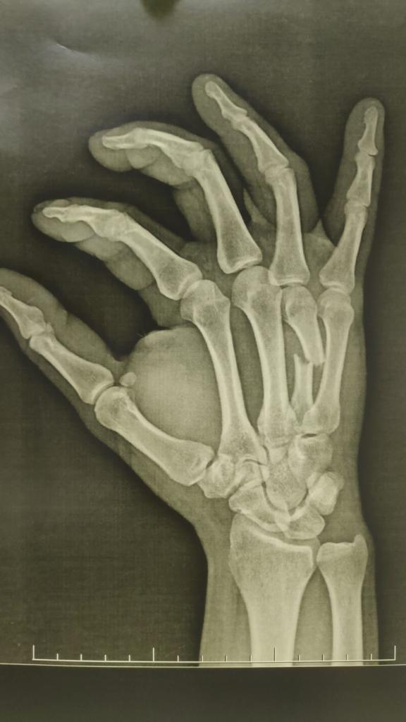  (A) |  | 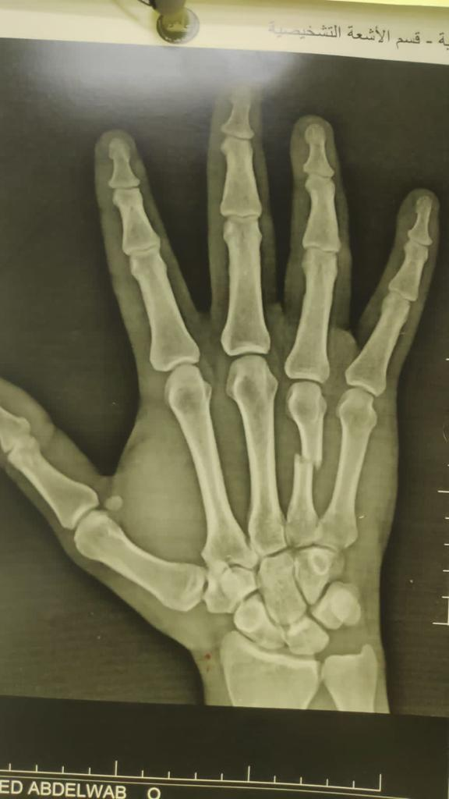  (B)
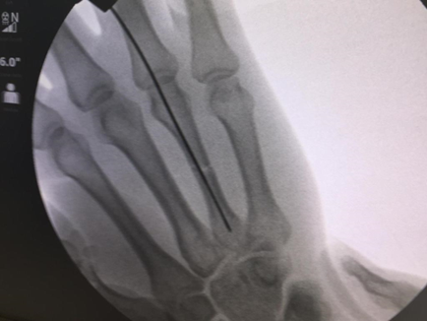  (C) |  | 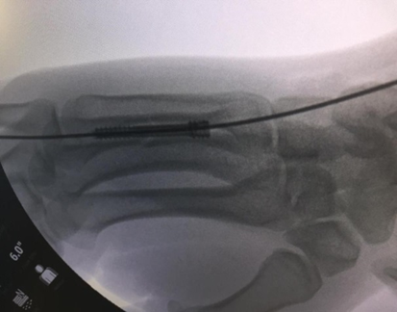  (D)
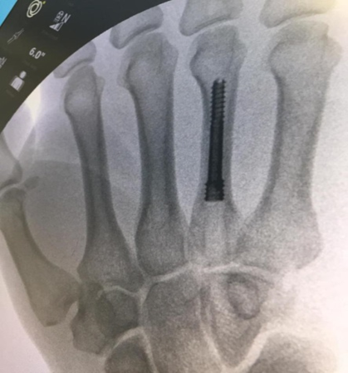  (E) |  | 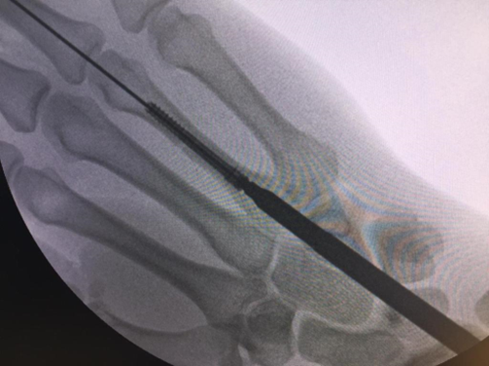  (F)
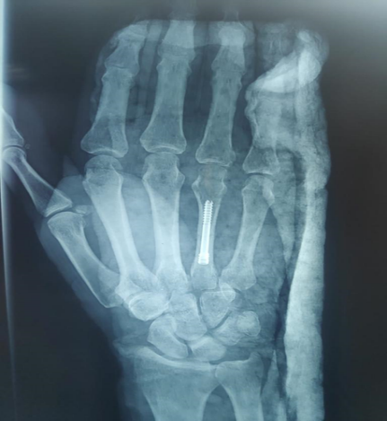  (G) | 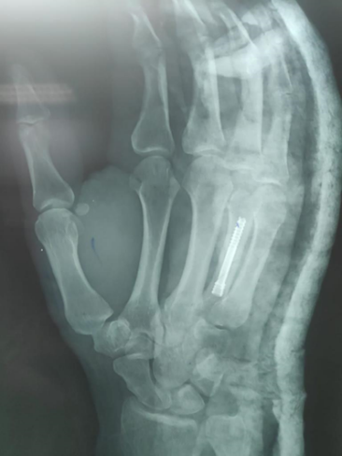  (H) |  | 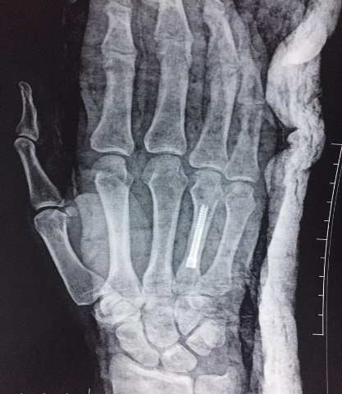  (I)
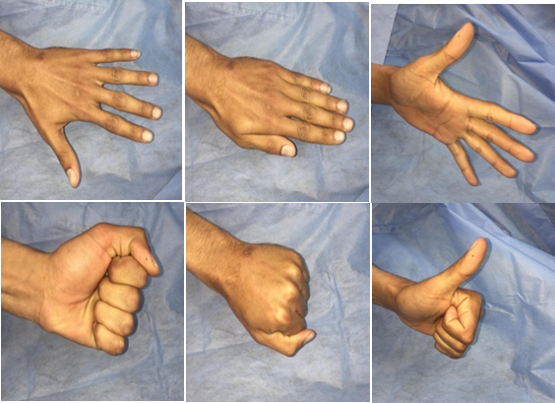
(J)
Figure 1: (A, B) fracture of 4th metacarpal, (C-F) intraoperative fixation of 4th metacarpal by Herbert screw, (G-I) Early follow up (1 week post-operative) x-rays ( P.A and Oblique views) showing stable uniting fracture, (J) Late clinical follow up photos showing near full ROM restored at the MCPJ and IPJ

Results
The current study carried on ten patients with metacarpal fractures underwent fixation by IMHS. There mean age was 30.8 ± 10.7 years. Most cases were males (90%) while females were (10%). According to fracture side, 3 cases (30%) had a fracture on the non-dominant hand, while 7 cases (70%) had a fracture on the dominant hand. Additionally, out of the total cases, 2 cases (20%) had a fracture on the left side, while 8 cases (80%) had a fracture on the right side. According to fracture location ,3 cases (30%) had a fracture in the neck of the metacarpal bone, while 7 cases (70%) had a fracture in the shaft of the metacarpal bone. Out of the total cases, 2 cases (20%) had a fracture in the 2nd metacarpal, 1 case (10%) had a fracture in the 3rd metacarpal, 3 cases (30%) had a fracture in the 4th metacarpal, and 4 cases (40%) had a fracture in the 5th metacarpal. In terms of mechanism of injury, 3 cases (30%) were caused by a direct injury, 2 cases (20%) were caused by falling down, 3 cases (30%) were caused by a punch, and 2 cases (20%) were caused by a road traffic accident (RTA). Out of the total cases, 5 cases (50%) had a transverse fracture pattern, 2 cases (20%) had an oblique fracture pattern, 2 cases (20%) had a spiral fracture pattern, and 1 case (10%) had a comminuted fracture pattern. Table 1
Table 1: Demographics and Fracture location in the studied cases among studied cases
 |  |  | Total patients (n=10)
Age (years) | Mean ± SD |  | 30.8 ± 10.7
Age groups , n(%) | <30 years |  | 6(60%)
Age groups , n(%) | 31.00 - 40.00 years |  | 1(10%)
Age groups , n(%) | >40 years |  | 3(30%)
Gender , n(%) | Female |  | 1(10%)
Gender , n(%) | Male |  | 9(90%)
Hand dominance | Non dominant |  | 3(30%)
Hand dominance | Dominant |  | 7(70%)
Side affected | Left |  | 2(20%)
Side affected | Right |  | 8(80%)
Fracture location | Neck |  | 3(30%)
Fracture location | Shaft |  | 7(70%)
Fractured metacarpal | 2nd metacarpal |  | 2(20%)
Fractured metacarpal | 3rd metacarpal |  | 1(10%)
Fractured metacarpal | 4th metacarpal |  | 3(30%)
Fractured metacarpal | 5th metacarpal |  | 4(40%)
Mechanism of injury | Direct |  | 3(30%)
Mechanism of injury | Falling down |  | 2(20%)
Mechanism of injury | Punch |  | 3(30%)
Mechanism of injury | RTA |  | 2(20%)
Fracture pattern |  | Transverse | 5(50%)
 |  | Oblique | 2(20%)
 |  | Spiral | 2(20%)
 |  | Comminuted | 1(10%)
RTA: road traffic accident
The mean operative time was 27.5 ± 6.8 minutes. The mean follow-up duration was 11.8 ± 1.8 months. The mean active range of motion (ROM) percentage was 91.9 ± 5.2 (%). The mean passive ROM percentage was 97.8 ± 3.1(%). The mean grip strength percentage was 95.5 ± 4.8 (%). Finally, the mean total active motion (TAM) in degrees was 258.3 ± 9.3. Table 2
Table 2: Operation time, follow up and Post operative assessment of the studied cases in the studied cases
 | Total patients (n=10)
 | Mean ± SD | Median (IQR)
Operative time (minutes) | 27.5 ± 6.8 | 27.5(20-30)
Follow up duration (months) | 11.8 ± 1.8 | 11.5(11-12)
Active ROM % | 91.9 ± 5.2 | 91.5(88-95)
Passive ROM % | 97.8 ± 3.1 | 99(98-100)
Grip strength % | 95.5 ± 4.8 | 95(95-100)
TAM (°) | 258.3 ± 9.3 | 259(250-265)
ROM: Range of motion; TAM: Total active motion
The mean Dash score was 1.6 ±1.5, a Dash score of 0 was reported in 4 cases (40%), a score of 2 was reported in 3 cases (30%), a score of 3 was reported in 2 cases (20%), and a score of 4 was reported in 1 case (10%). According to Belsky score, 50% of cases had excellent score and 50% had good Belsky score. The mean time needed to union was 8±1 months. Out of the total cases, 1 case (10%) had a time lapse to union of 6 months, 3 cases (30%) had a time lapse to union of 7 months, and 6 cases (60%) had a time lapse to union of 8 months. Table 3
Table 3: Dash score and Belsky score in the studied cases
 |  | Total patients (n=10)
Dash score | Mean ± SD | 1.6 ± 1.5
Dash score | Median (IQR) | 2(0-4)
Dash score, n(%) | 0 | 4(40%)
Dash score, n(%) | 2 | 3(30%)
Dash score, n(%) | 3 | 2(20%)
Dash score, n(%) | 4 | 1(10%)
Belsky score | Excellent | 5(50%)
Belsky score | Good | 5(50%)
Time lapse to union (months) | M ± SD | 8 ±1
Time lapse to union, n(%) | 6 months | 1(10%)
Time lapse to union, n(%) | 7 months | 3(30%)
Time lapse to union, n(%) | 8 months | 6(60%)
NUSS: new Non-Union Scoring System
Regarding the outcome, the mean pain score was 0.9 ±1.1, Out of the total cases, a pain score of 0 was reported in 5 cases (50%), a score of 1 was reported in 2 cases (20%), a score of 2 was reported in 2 cases (20%), and a score of 3 was reported in 1 case (10%). According to complications, the majority of cases had no complications (80%), one case had shortening, and one cases had stiffness. Table 4

Table 4: Pain assessment and complication in the studied cases
 |  | Total patients (n=10)
Pain score | Mean ± SD | 0.9 ± 1.1
Pain score | Median (IQR) | 0.5(0-2)
Pain score, n (%) | 0 | 5(50%)
Pain score, n (%) | 1 | 2(20%)
Pain score, n (%) | 2 | 2(20%)
Pain score, n (%) | 3 | 1(10%)
Complications, n (%) | No complications | 8(80%)
Complications, n (%) | Shortening | 1(10%)
Complications, n (%) | Stiffness | 1(10%)

Discussion
A range of 18–44% of all hand fractures are classified as metacarpal fractures. Approximately 88% of all metacarpal fractures occur in the non-thumb metacarpals, with the fifth finger being the most often affected. ^{[10]}.
Isolated, closed, simple and stable injuries comprise the majority of metacarpal fractures. Although several metacarpal fractures exhibit favourable outcomes without requiring surgical intervention, there is a scarcity of data and ongoing debate over the optimal treatment regimen that might assist the attending physician ^{[11]}.
Unstable metacarpal shaft fractures can be fixed using a number of methods, such as lag screw fixation, dorsal plating, and K-wire constructs ^{[12]}. IMHS stabilization of these fractures has grown in popularity in recent years ^{[13]}.
Acceptable criteria of deformity vary considerably in the literature despite their prevalence, and there is no consensus about the optimal therapy strategy. Different casting techniques, splints, and closed reduction or free mobilization are examples of nonsurgical treatment. Surgical techniques include intraosseous wires, Kirschner wire (K-wire) fixation, interfragmentary compression screws, external fixators, or plates ^{[14]}.
Hand function is reduced for a duration of weeks to months throughout the rehabilitation process, which is a prerequisite for both nonsurgical and surgical therapies in addition to the significant resources required. Due to the necessity for specialised resources, additional equipment, and theatre use, surgical therapy is considered to be more expensive ^{[11]}.
Our objective was to evaluate and compare the functional, clinical and radiological outcome of fixing unstable metacarpal fractures using antegrade IMHS (Herbert Screws).
This study was conducted on carried on ten cases with metacarpal fractures who were subjected to fixation by IMHS. In our study, there mean age was 30.8 ± 10.7 years. Most cases were males (90%) while females were (10%).
Similarly, Siddiqui et al. ^{[15]} included 32 cases with metacarpal fracture, six were females whereas 26 were males, with a mean age of 30.9 years ± 13.1 years in all cases.
Furthermore, Dyrna et al. ^{[16]} compared the stability of IMHS fracture fixation to that of other prevalent rigid fixation techniques in two distinct kinds of metacarpal shaft fractures: Through dorsal plating and lag screw fixation, five matched paired hands were studied (age 60.9 ± 4.6 years).
In the current work, according to fracture side, 3 cases (30%) had a fracture on the non-dominant hand, while 7 cases (70%) had a fracture on the dominant hand. Additionally, out of the total cases, 2 cases (20%) had a fracture on the left side, while 8 cases (80%) had a fracture on the right side.
In agreement with our study, Raghavendra et al. ^{[17]} enrolled 30 cases with metacarpal fractures who were treated surgically using plate and screw or k-wire. A 73.33% dominance of right-handed individuals is seen in their series, as opposed to the left-handed.
Couceiro et al. ^{[18]} compared the intramedullary fixation of metacarpal fractures with antegrade Kirschner wires and cannulated headless screws. The study incorporated a total of thirty fractures, 11 of which were fixed using Kirschner wire and 19 with screws. With the exception of one, all of the patients were determined to be right-handed.
In our study, according to fracture location ,3 cases (30%) had a fracture in the neck of the metacarpal bone, while 7 cases (70%) had a fracture in the shaft of the metacarpal bone. Out of the total cases, 2 cases (20%) had a fracture in the 2nd metacarpal, 1 case (10%) had a fracture in the 3rd metacarpal, 3 cases (30%) had a fracture in the 4th metacarpal, and 4 cases (40%) had a fracture in the 5th metacarpal.
Ruchelsman et al. ^{[19]} investigated clinical and radiographic results in patients with metacarpal neck and shaft fractures treated with limited-open retrograde IMHS fixation. Data on a sequential series of 39 patients was obtained prospectively. Acute displaced metacarpal neck/subcapital syndrome was documented in 26 cases, whereas shaft fractures were recorded in 13 cases.
In terms of mechanism of injury, 3 cases (30%) were caused by a direct injury, 2 cases (20%) were caused by falling down, 3 cases (30%) were caused by a punch, and 2 cases (20%) were caused by a road traffic accident (RTA).
Road traffic accidents accounted for the majority of injuries (50%), according to the findings of Raghavendra et al. ^{[17]}. Self-fall was the second most common cause of injury (26.66%).
a retrospective study by Tobert et al. ^{[20]} assessed the clinical outcomes of retrograde IMHS fixation for metacarpal fractures analyzing 16 patients who received IMHS fixation for 18 metacarpal fractures. The injury mechanisms identified encompassed forceful object impact (affecting eight cases), falls (affecting five cases), and sports-related incidents (two cases). A dog bite was sustained by one patient.
In the current study, out of the total cases, 5 cases (50%) had a transverse fracture pattern, 2 cases (20%) had an oblique fracture pattern, 2 cases (20%) had a spiral fracture pattern, and 1 case (10%) had a comminuted fracture pattern.
Raghavendra et al. ^{[17]} established that the transverse fracture pattern was observed in the majority of cases in their investigation, as the bulk of shaft fractures (16 instances) and all neck fractures were transverse in nature.
Our findings showed that the mean operative time was 27.5 ± 6.8 minutes. The mean follow-up duration was 11.8 ± 1.8 months.
Compatible with our findings, Jann et al. ^{[12]} analysed the outcomes of cannulated compression screw treatment for twenty unstable metacarpal fractures in fifteen patients. Their study revealed that the mean surgical duration was 21 minutes.
In our study, the mean active ROM percentage was 91.9 ± 5.2 (%). The mean passive ROM percentage was 97.8 ± 3.1(%). The mean grip strength percentage was 95.5 ± 4.8 (%). Finally, the mean total active motion (TAM) in degrees was 258.3 ± 9.3(°). The mean Dash score was 1.6 ±1.5, a Dash score of 0 was reported in 4 cases (40%), a score of 2 was reported in 3 cases (30%), a score of 3 was reported in 2 cases (20%), and a score of 4 was reported in 1 case (10%).
Siddiqui et al. The mean total active ROM in the fractured hand after surgery was determined to be 242.8 ± 14.5 degrees by Siddiqui et al. ^{[15]}. Also, a mean grip strength of 37.8 ± 7.3 kilos was observed after the operation.
A retrospective chart review was conducted by Gaspar et al. ^{[21]} on proximal phalanx fractures that were treated with dual antegrade IMHS fixation and had a follow-up period of one-year minimum. It was observed that mean grip strength was 97% of the uninjured side, final postoperative total active motion was 258°, and Quick DASH score was 3.9.
While one research (n=18) did not document MCP flexion, it did show that each digit exhibited a total active motion exceeding 240 degrees ^{[22]}.
We found that according to Belsky score, 50% of cases had excellent score and 50% had good Belsky score. In the current study, the mean time needed to union was 8±1 months. Out of the total cases, 1 case (10%) had a time lapse to union of 6 months, 3 cases (30%) had a time lapse to union of 7 months, and 6 cases (60%) had a time lapse to union of 8 months.
Ruchelsman et al. ^{[19]} observed that all cases achieved radiographic union by 6 weeks. Jann et al. ^{[12]} demonstrated that there were no radiographic malunions at the last follow-up.
The mean pain score was 0.9 ±1.1, Out of the total cases, a pain score of 0 was reported in 5 cases (50%), a score of 1 was reported in 2 cases (20%), a score of 2 was reported in 2 cases (20%), and a score of 3 was reported in 1 case (10%).
In consistency, Couceiro et al. ^{[18]} concluded that the mean pain on VAS score for the screw group was 1 (0–4). In a study by Siddiqui et al. ^{[15]}, they found that the mean VAS score for pain was 7.5 ± 1.7 at the time of presentation.
According to complications, the majority of cases had no complications (80%), one case had shortening, and one cases had stiffness.
Gaspar et al. ^{[21]} showed that no complications arose, and no cases required subsequent surgical operations.
A comparable overall complication rate (16%) was documented in two large series subsequent to percutaneous Kirschner wire fixation of many hand and wrist fractures ^{[23, 24]}.
Limitations: The research was conducted at a single centre using a relatively limited sample size of only 10 patients which may limit the generalizability of the current study. The follow-up period was limited to three months postoperatively, which may not capture long-term outcomes or potential complications that could arise after a longer duration. The study did not provide information on long-term outcomes, such as functional recovery beyond the three-month follow-up period or patient-reported outcomes in the extended postoperative period.
We recommended that further clinical studies are needed with multicenter cooperation to validate our findings. Long-term radiological evaluations, functional assessments, and patient-reported outcomes should be included to evaluate factors such as bone healing, maintenance of alignment, and functional recovery beyond the initial postoperative phase.
Conclusions: Fixation of unstable metacarpal fractures using IMHS (Herbert screws) resulted in favorable functional, clinical, and radiological outcomes. The use of Herbert screws allowed for successful fracture reduction and union, with good ROM, grip strength, and overall patient satisfaction. The low incidence of complications further supports the efficacy and safety of this fixation method. These findings suggest that IMHS can be considered as a reliable option for the operative treatment of unstable metacarpal fractures, providing clinicians with a valuable alternative in their surgical decision-making process.
Financial support and sponsorship: Nil
Conflict of Interest: Nil

References
1. Ye J, Li Q, Nie J. Prevalence, characteristics, and associated risk factors of wrist fractures in americans above 50: The cross-sectional NHANES Study. Front Endocrinol (Lausanne). 2022;13:800-9.
2. Neumeister MW, Winters JN, Maduakolum E. Phalangeal and metacarpal fractures of the hand: Preventing stiffness. Plast Reconstr Surg Glob Open. 2021;9:38-56.
3. Li Y, Zhou Y, Zhang X, Tian D, Zhang B. Incidence of complications and secondary procedure following distal radius fractures treated by volar locking plate (VLP). J Orthop Surg Res. 2019;14:295-308.
4. Guidi M, Frueh FS, Besmens I, Calcagni M. Intramedullary compression screw fixation of metacarpal and phalangeal fractures. EFORT Open Rev. 2020;5:624-9.
5. Chao J, Patel A, Shah A. Intramedullary screw fixation comprehensive technique guide for metacarpal and phalanx fractures: Pearls and pitfalls. Plast Reconstr Surg Glob Open. 2021;9:38-56.
6. Vassa R, Garg A, Omar IM. Magnetic resonance imaging of the wrist and hand. Pol J Radiol. 2020;85:461-88.
7. Müller FC, Gosvig KK, Børgesen H, Gade JS, Brejnebøl M, Rodell A, et al. Dual-energy CT for suspected radiographically negative wrist fractures: A prospective diagnostic test accuracy study. Radiology. 2020;296:596-602.
8. Delgado DA, Lambert BS, Boutris N, McCulloch PC, Robbins AB, Moreno MR, et al. Validation of digital visual analog scale pain scoring with a traditional paper-based visual analog scale in adults. J Am Acad Orthop Surg Glob Res Rev. 2018;2:88-91.
9. Gavurova B, Dvorsky J, Popesko B. Patient satisfaction determinants of inpatient healthcare. Int J Environ Res Public Health. 2021;18:34-9.
10. Fatima A, Ahmed O, Ahmed M, Beg MSA, Batool A, Siddiqui MM. Metacarpal fractures, management techniques, and outcomes in our center. Cureus. 2021;13:178-98.
11. Taha RHM, Grindlay D, Deshmukh S, Montgomery A, Davis TRC, Karantana A. A systematic review of treatment interventions for metacarpal shaft fractures in adults. Hand (N Y). 2022;17:869-78.
12. Jann D, Calcagni M, Giovanoli P, Giesen T. Retrograde fixation of metacarpal fractures with intramedullary cannulated headless compression screws. Hand Surg Rehabil. 2018;37:99-103.
13. Beck CM, Horesh E, Taub PJ. Intramedullary screw fixation of metacarpal fractures results in excellent functional outcomes: A literature review. Plast Reconstr Surg. 2019;143:1111-8.
14. Retrouvey H, Morzycki A, Wang AMQ, Binhammer P. Are we over treating hand fractures? Current practice of single metacarpal fractures. Plast Surg (Oakv). 2018;26:148-53.
15. Siddiqui AA, Kumar J, Jamil M, Adeel M, Kaimkhani GM. Fixation of metacarpal fractures using intramedullary headless compression screws: A tertiary care institution experience. Cureus. 2019;11:44-66.
16. Dyrna FGE, Avery DM, Yoshida R, Lam D, Oeckenpöhler S, Cote MP, et al. Metacarpal shaft fixation: a biomechanical comparison of dorsal plating, lag screws, and headless compression screws. BMC Musculoskeletal Disorders. 2021;22:335-9.
17. Raghavendra V, Motten T. Evaluation of surgical management of metacarpal fractures-A prospective clinical study. Int J Orthop. 2017;3:503-6.
18. Couceiro J, Ayala H, Sanchez M, De la Red MLA, Velez O, Del Canto F. Intramedullary screws versus kirschner wires for metacarpal fixation, functional, and patient-related outcomes. Surg J (N Y). 2018;4:29-33.
19. Ruchelsman DE, Puri S, Feinberg-Zadek N, Leibman MI, Belsky MR. Clinical outcomes of limited-open retrograde intramedullary headless screw fixation of metacarpal fractures. J Hand Surg Am. 2014;39:2390-5.
20. Tobert DG, Klausmeyer M, Mudgal CS. Intramedullary fixation of metacarpal fractures using headless compression screws. J Hand Microsurg. 2016;8:134-9.
21. Gaspar MP, Gandhi SD, Culp RW, Kane PM. Dual antegrade intramedullary headless screw fixation for treatment of unstable proximal phalanx fractures. Hand (N Y). 2019;14:494-9.
22. Beck CM, Cornejo M, Taub PJ. Abstract: Outcomes of intramedullary fixation of metacarpal fractures using headless compression screws: A literature review. Plast Reconstr Surg. 2017;5:153-78.
23. Hsu LP, Schwartz EG, Kalainov DM, Chen F, Makowiec RL. Complications of K-wire fixation in procedures involving the hand and wrist. J Hand Surg Am. 2011;36:610-6.
24. Stahl S, Schwartz O. Complications of K-wire fixation of fractures and dislocations in the hand and wrist. Arch Orthop Trauma Surg. 2001;121:527-30.

